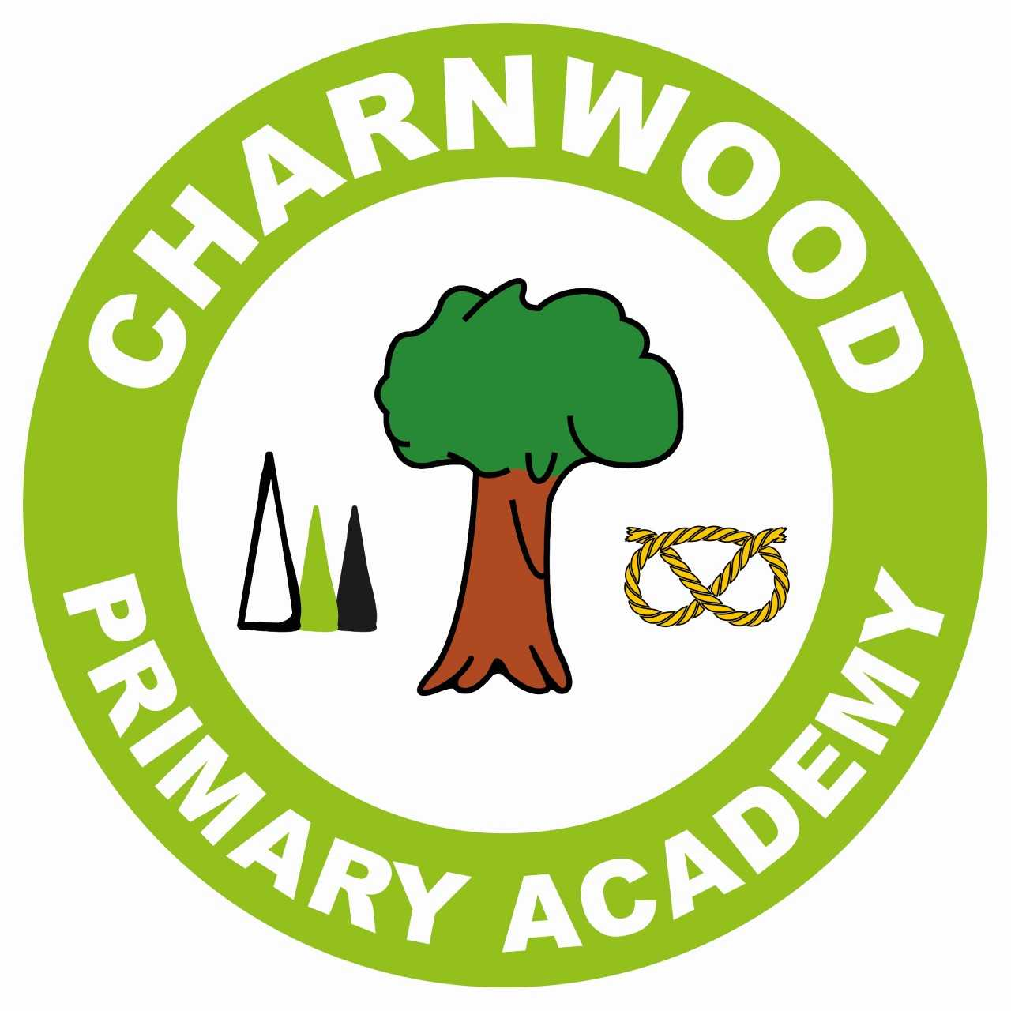


NURSERY APPLICATION
Admission to Charnwood Primary Academy September 2025

Should you wish to apply for a Nursery place for your child for September 2024, please complete and return this application form as soon as possible directly to Charnwood Primary Academy, Purcell Avenue, Lichfield WS13 7PH.

Completed forms to be returned to the school office by Monday 29th April 2024
CHILD’S DETAILS

Child’s Legal Surname: Date of Birth:
Child’s Legal First Name: Male:  Female: 

Full Postal Address:
(including postcode)

NB: it is your responsibility to advise Charnwood Primary Academy immediately if these details change.

Present Nursery/Childcare Setting:

Is your child a twin or triplet etc.? (one of multiple birth) Yes No

If yes, please provide the names of related applications:

NB. Please complete a separate application form for each sibling wishing to join Nursery

NURSERY HOURS
All children Aged 3 years and above are entitled to 15 hours Nursery funding per week
(referred to as ‘Universal Funded Hours’).
Yes | No
Please tick whether you qualify for 30 hours funding per week?
(15 hours universal entitlement plus an additional 15 hours hrs)

Is this child in the care of a local authority?
Yes | No

Has the child previously been in the care of a local authority but has since been adopted (or become subject to a residence order or special guardianship order since being in public care)?
Yes | No

If ‘Yes’ to either of the above, please provide Social Worker and Local Authority contact details in the box below:

Yes | No
Is your child from a returning Service/Crown Servant family?

Does your child have an Education, Health and Care plan?
Yes | No

DETAILS OF PERSON COMPLETING THIS FORM

Surname: Please indicate title Mr / Mrs / Miss / Ms

First Name:

Relationship to Child:

Contact Telephone Number:

Email Address:
If you are caring for someone else’s child for more than 28 days and are not an immediate relative, you may be privately fostering and it is a legal requirement that you contact the local authority on 0800 1313126. Further information is available at www.staffordshire.gov.uk.

DETAILS OF ANY OLDER BROTHER OR SISTER ATTENDING CHARNWOOD PRIMARY ACADEMY
(Please note that the older brother or sister must still be in attendance at the school in September 2024, and permanently living at the same address)

Name of Sibling Date of Birth

Current Year Group

PLEASE STATE YOUR REASONS FOR CHOOSING CHARNWOOD PRIMARY ACADEMY

If there are any personal circumstances relating to your preference that you are not happy to disclose on this form, please tick the box and we will arrange to contact you.

It is important that you read and understand our admissions policy which can be found on the website www.charnwood.staffs.sch.uk under Academy Information, Policies, Admission Arrangements 2024/25.

DECLARATION AND SIGNATURE OF APPLICANT
The information provided on this application form will be used to ensure that our records are correct. It may also be shared with other agencies and service providers to ensure that your child receives an appropriate service. You can find out more about our privacy policy for Parents and Pupils by visiting www.charnwood.staffs.sch.uk, Academy Information, Policies.
I certify that the information I have provided is true to the best of my knowledge, and understand that any false or deliberately misleading information provided on this form and/or supporting papers may render this application invalid and could lead to the withdrawal of an offer of a Nursery school place for my child

Before returning this form please sign to agree that you have:
- consulted with any other persons who have parental responsibility for this child
- provided any supportive evidence required to assess your application
Signature: Date:

HELPLINE: If you require any assistance please telephone 01543 227560 EMAIL: admin@charnwood.staffs.sch.uk or office@charnwood.staffs.sch.uk

