Charnwood Primary Academy SEND Policy
2025 – 2026


Our School  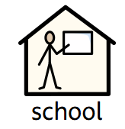 | Our School Vision  Charnwood’s core moral purpose is encapsulated in the vision statement for the Academy: Inspire...Nurture...Achieve.  Our focus is on learning not just within and across subject areas but also the personal development of all learners who attend our academy. We strive to inspire all learners to go beyond what they consider possible for themselves, to experience and try new things and to realise all aspects of their potential.  At Charnwood Primary Academy, we believe that every pupil, regardless of gender, race or disability, has a right to equal access to a broad and balanced curriculum. We consider it essential that the curriculum is presented in a supportive and stimulating atmosphere, which values each child and encourages him or her to achieve his or her full potential.  January 2025 Information  Charnwood currently has 220 children on role  There are currently 57 children on the SEND register with a range of needs from universal to specialist. (25% compared to last year 25% )  2 children that have an EHCP (2%) and 5 children have a SEND Support Provision Plan (3.4%)  The SENDCO is Mrs Stafford  If you would like to contact Mrs Stafford please call or email the office on 01543227560 or office@charnwood.staffs.sch.uk
Policy introduction  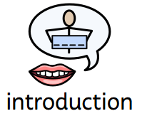 | Introduction  This policy complies with the statutory requirements laid out in the SEND Code of Practice 0 - 25 years (2015). It will also take into account statutory and non-statutory related guidance, including, but not limited to:  - SEN Code of Practice 0-25 (2015)  - Disability and Discrimination Act 1995  - Equality Act 2010  - Children and Families Act 2014  - Supporting Children with Medical Conditions.  - Keeping Children Safe in Education.  - Working Together to Safeguard Children.  Aims of our SEND policy  The aims of our special educational need and disability policy and practice are:  - To provide access for all pupils to a broad and balanced curriculum and all aspects of school life.  - To involve children, parents and young people in decision making.  - To ensure collaboration between education, health and social care services to provide support.  - To support all staff in acquiring expertise to meet the needs of all pupils including those with SEND.  - To reduce barriers to progress and learning by embedding the principles in the National Curriculum Inclusion statement. https://www.gov.uk/government/collections/national- curriculum.  - To use our best endeavours where needed to secure special educational provision for pupils for whom this is required, that is “additional to and different from” that provided within the differentiated curriculum to better respond to the four areas of need:  - Communication and interaction  - Cognition and learning  - Social, mental and emotional health.  - Sensory and/or physical.
Policy development and implementation   | The policy has been created by the school’s SENCo in line with the legislation listed and our admission arrangements. Our governors, Headteacher and staff were consulted. The SENDCo is responsible for the design and implementation of this policy. Stakeholders are able to access this document via our website.  The SENDCO is Mrs Stafford  If you would like to contact Mrs Stafford please call or email the office on 01543227560 or office@charnwood.staffs.sch.uk
Identifying and Assessing Need  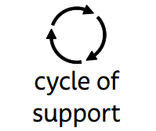 | 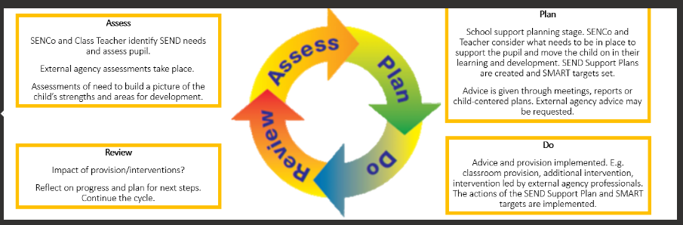  Supporting children and young people with SEND with or without an Education Health Care Plan:  We support children and young people with SEND with or without an Education Health Care Plan through quality first teaching (QFT) within the classroom. At times during their school career, children may need to receive additional targeted support during a lesson or a term depending on their needs. This is delivered through an adaptive teaching approach that includes the ‘additional to’ or ‘different from’ support that is planned or provided in response to a child’s need at the time of learning, within the whole class or within a small group.  Planning the Support:  Should a child require significant long term additional support, school follows the processes of a Graduated Response. This means that your child’s support reflect the level of need required and is considered carefully of a regular basis. The SEND Graduated Response process follows the minimum termly cycles of Assess, Plan, Do, Review in line with the SEND Code of Practice. Within each cycle the following may occur:  Step 1: Assess / Do  - Formal learning assessments may take place and/or the teacher indicates that the child is not making sufficient progress, therefore reasonable adjustments, basic skills provision or physical adaptations to support needs through Wave 1 Quality First Teaching are made.  - The class teacher will inform Parents/carers of the concern verbally.  - The class teacher will inform the SENCO of their initial concern and the actions they take.  Step 2: Assess / Do  - If a concern continues over time, further support / adjustments will be made to support the child for minimum 6 weeks by the class teacher.  - The teacher monitors and reviews the outcome of the additional support / adjustments  - If further intervention may be required, class teachers will raise this at a Pupil Progress meeting with the Headteacher and / or in a SEND meeting with the SENCO, both of which are held termly – although they are able to discuss their concerns with either party at any time.  Step 3: Review / Plan  - The SENCO reviews evidence with class teacher / assessment outcomes / external agency information and discusses the pupil with the class teacher.  - If the child meets SEND criteria, the SENCO will contact parents to discuss their child in initial meeting, where the current needs and support required is discussed.  - The teacher may write an Individual support plan (ISP) after this meeting and the Parent is requested to sign and return the support plan.  - The SENCO notes the provision in place on provision map & then adds child to the school’s SEND Register, ensuring additional provision is put into place.  Teaching, Learning and Support  - If the outcome of the meeting does not result in the child meeting the criteria for the SEND register, the SENCO will add them to the Monitoring / Vulnerable Register and consider the next steps to support the child in conjunction with Parents/carers and staff. This may involve the use of other agencies and referrals may be made.  Step 4: Formal Registration of SEND and Plan for Support (Do)  - A Individual Support plan (ISP) or learning records the targets and support needs of a child on the SEND register.  - An ISP is used for planning and preparation: It is a working document to inform teaching staff, support staff and parents of the child’s current identified needs  - An ISP is shared with other staff working with child and support put in place by the class teacher as agreed with the SENCO during the term.  Step 5: Review  - An ISP is reviewed 3 times a year with teacher overseen by SENCo: January, April and July/September .  - An ISP is then shared and discussed with parents at the start of each term.  - These meetings allow for any changes in pupil needs to be shared, which may result in the pathway of support being changed.  These SEND Review meetings may lead to:  - Movement of the child to the monitoring / vulnerable register – no ISPS  - Continued SEND support with new ISP targets written by teacher (with advice and agreement with the SENCO)  - A referral to outside agency by SENCO for additional advice or support  An application for an EHC plan (if there is sufficient evidence to meet Staffordshire Criteria)  Exiting the SEND Register:  If the child makes accelerated progress, intervention will be stepped down but the child’s progress will continue to be monitored. Parents will be consulted and the mutual decision will be made to remove the children from the SEN register. This will be done in consultation with parents.  Individual Learning Plans:  Charnwood Primary Academy uses ILP’s to identify pupils needs and set out measurable targets to help address these. Strategies to enable the child to meet their targets will be recorded in an ILP. An ILP will be used as part of the Assess, Plan, Do, Review cycle. The ILP will identify a pupil’s immediate learning needs and the special arrangements that need to be made to suit the individual pupil. The ILP also describes the arrangements made to monitor and review progress and ensure that pupil entitlement is met.  The ILP should include:  - Short term targets for the child (3 or 4)  - Teaching strategies to be used  - Provision to be put in place  - Success Criteria for meeting the targets  - Review date  - Outcomes of action taken  The ILP will be reviewed at least termly and parents’ views on the child’s progress will be sought. Wherever possible the child will take part in the review and help to set targets.  Pupil Passports:  Charnwood Primary Academy uses Learning passports to identify pupils needs and strategies required to address these. They are used to outline strategies used to enable a child to access the curriculum. They are not target based, however they still evidence areas of need and progress made by children. A child may have a Pupil Passport in addition to an ILP, or they may just have a Pupil Passport.  The Pupil Passport should include:  - The views of the pupil on what is working well in school  - The views of the pupil on what could be better in school  - Strategies to support the pupil in accessing the school day and/or curriculum  - The views of the child’s parents
Roles and responsibilities  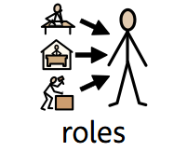 | Responsibilities  All members of the school community should be aware of the procedures for identifying, assessing and making provision for children with special educational needs. Regular training is given to all staff to ensure they are aware and able to carry out their responsibilities.  The Governors:  The Governing Body (LAC) are responsible for ensuring that they use their best endeavours to meet the needs of children and young people with special educational needs in their school.  The Headteacher:  The Headteacher as the leader of the school is responsible for ensuring that this is translated into reality in the running of the school.  The SENDCO:  The named SENDCo is Mrs A Stafford  Responsibilities will include.  - Overseeing the day-to-day operation of the school’s SEND policy  - Co-ordinating provision for children with special educational needs  - Liaising with and advising other teachers  - Managing teaching assistants and 1:1 support assistants  - Overseeing the records of all children with special educational needs  - Liaising with parents of children with special educational needs  - Contributing to the in-service training of staff  - Liaising with external agencies.  Class Teachers:  - Pupils with SEND are the responsibility of the class teacher  - In conjunction with the SENDCO write targets  - Implement and resource Assess, Plan, do, review cycle  - Discuss with TA’s strategies and resources to implement targets and interventions  - Communicate with parents regarding progress  - Monitor and evaluate pupil progress with TA’s and instigate further action/strategies.  Teaching Assistants:  Teaching assistants working with children identified as having special educational needs will:  - Support the class teacher by working with SEND pupils either individually or in groups  - Have a clear understanding of the child’s /group targets and the resources to be used  - Monitor progress on a weekly basis in an agreed format  - Receive feedback from the class teacher and receive new guidance on the basis of the feedback.
Admissions   | The school will admit pupils with already identified special educational needs as well as identifying and providing for pupils not previously identified as having special educational needs.
Staff training | What training are the staff supporting children and young people with SEND had or are having?  The school is committed to ensuring staff are highly trained. The SENCO attends termly updates arranged through Staffordshire University Academy Trust. Additional SEN training is delivered according to need. The SENCO has completed the National SENCO award.
   |  |  | 
  Arithmetic and the use of concrete resources | Scaffolding | Phonics and Early reading | Reading for those who struggle
   |  | 
  Specific Learning Difficulties | Colourful semantics within the writing journey | Speech, Language and communication
Monitoring and evaluating the policy  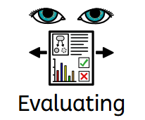 | The SENDCO is responsible for the development, implementation and review of the policy. The policy is developed by SENDCO with support from Headteacher.  Policy approved by the LAC:  Policy will be reviewed by:
Schools are also required to produce an SEN information report on an annual basis  (statutory requirement | SEN Information report can be viewed on the school website

